DLD LAB 02 SUBMISSION:
Name: Yash Raj
Roll-Number: 24k-0737
Lab Task#1:
Write Boolean Expression And Truth Table Of Given Circuit:
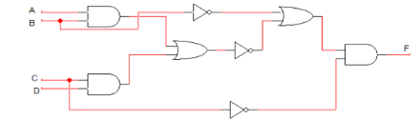
Boolean Expression:
((AB+CD)'+B').C'
Truth Table:
A | B | C | D | AB | CD | AB+CD | (AB+CD)’ | B’ | (AB+CD)’+B’ | C’ | OUTPUT
0 | 0 | 0 | 0 | 0 | 0 | 0 | 1 | 1 | 1 | 1 | 1
0 | 0 | 0 | 1 | 0 | 0 | 0 | 1 | 1 | 1 | 1 | 1
0 | 0 | 1 | 0 | 0 | 0 | 0 | 1 | 1 | 1 | 0 | 0
0 | 0 | 1 | 1 | 0 | 1 | 1 | 0 | 1 | 1 | 0 | 0
0 | 1 | 0 | 0 | 0 | 0 | 1 | 1 | 0 | 1 | 1 | 1
0 | 1 | 0 | 1 | 0 | 0 | 1 | 1 | 0 | 1 | 1 | 1
0 | 1 | 1 | 0 | 0 | 0 | 1 | 1 | 0 | 1 | 0 | 0
0 | 1 | 1 | 1 | 0 | 1 | 1 | 0 | 0 | 0 | 0 | 0
1 | 0 | 0 | 0 | 0 | 0 | 0 | 1 | 1 | 1 | 1 | 1
1 | 0 | 0 | 1 | 0 | 0 | 0 | 1 | 1 | 1 | 1 | 1
1 | 0 | 1 | 0 | 0 | 0 | 0 | 1 | 1 | 1 | 0 | 0
1 | 0 | 1 | 1 | 0 | 1 | 1 | 0 | 1 | 1 | 0 | 0
1 | 1 | 0 | 0 | 1 | 0 | 1 | 0 | 0 | 0 | 1 | 0
1 | 1 | 0 | 1 | 1 | 0 | 1 | 0 | 0 | 0 | 1 | 0
1 | 1 | 1 | 0 | 1 | 0 | 1 | 0 | 0 | 0 | 0 | 0
1 | 1 | 1 | 1 | 1 | 1 | 1 | 0 | 0 | 0 | 0 | 0

POST LAB TASK:
- (A + B) (B + C)
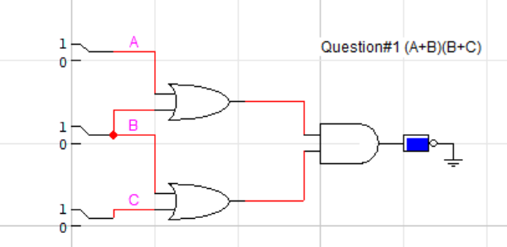

- (AB + C) D
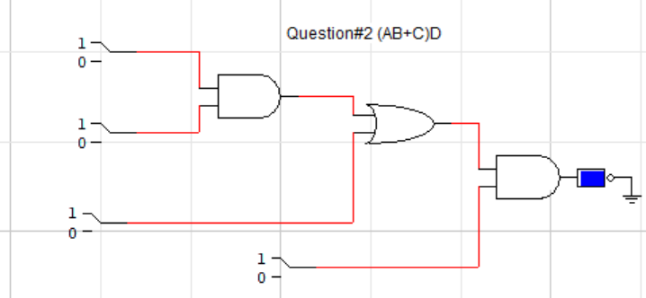

- ((A + B’C) (A + BC))’
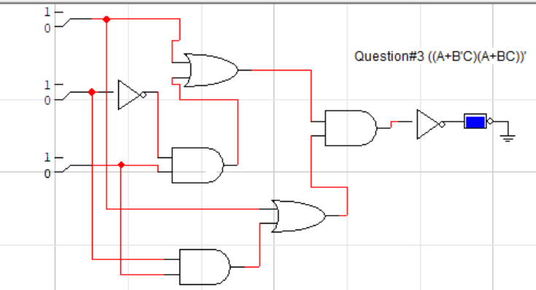

- A’BC + AB’C + ABC’ + (ABC)’
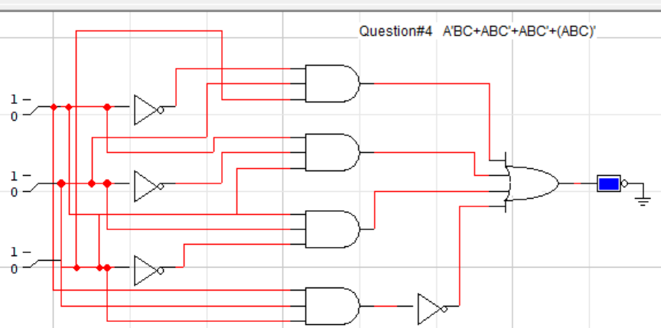

- (A’ + BC)’
